Men invited to create life-long reminders
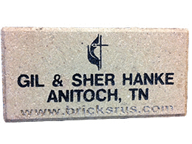Photo - Sample paver
NASHVILLE, Tenn. –– UM men are invited to purchase life-long reminders of those they love or wish to recognize on engraved pavers on the walkway in front of the Nashville office of the General Commission on UM Men.
Purchase of the pavers will not only honor a loved one, it will also support the international ministries of the commission.
People who reserve spaces prior to March 2012 will be guaranteed premium locations. The pavers will be installed soon after the March1-4, 2012, meeting of the National Association of Conference Presidents. People may still order pavers after that date, but they will not be guaranteed premium locations.
Engraved pavers come in two sizes: 8" x 8" ($500) and 4" x 8" ($200). One hundred percent of the donation is tax deductible.

How to order and pay?
To order call Marc at 615.620.7262, or order online now http://www.gcumm.org/support/paver-project Please scroll to the bottom of the page under “Payments” and enter the dollar amount, then out to right side enter the information to be put on the brick. Please start with BRICK then the two lines for the engraving: Mr. and Mrs. John Doe,

