Clergyman reunites with his former mentor
November 11, 2015 · Scouting
- 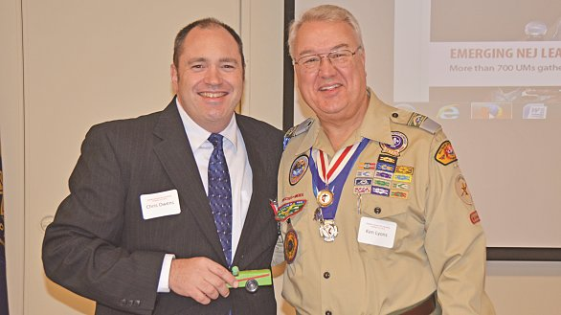

Photo: The Rev. Chris Owens (left) reunites with his former teacher, the Rev. Ken Lyons,

By Erik Alsgaard
FULTON, Md.––When he was in second grade, Chris became a Cub Scout. He joined scouting because his cousin was always “out doing really fun stuff, like camping.”
Chris wasn’t raised in the church. In fact, the only time he attended church was on Scout Sundays.
To his surprise, his mother enrolled him in the “God and Family” program which happened to meet at Baldwin Memorial UMC in Millersville. The pastor of the church and the leader of this program at that time was the Rev. Ken Lyons, and he required everyone to bring a Bible to every session.
Introduced to Bible
Chris found a Bible at home; it hadn’t been touched in decades.
Lyons showed Chris and the others how to use it. “That’s the first time I ever learned how to use a Bible,” Chris said.
Chris also learned, for the first time, at age 9, that the church—specifically, The United Methodist Church—is a warm, welcoming group of people.
Eventually, Chris’s cousin became an Eagle Scout and, at the age of 18; so did Chris.
“My scouting experience has prepared me for a lifetime of leadership and cultural impact with integrity and honor,” said Chris –– the Rev. Chris Owens, now pastor at Trinity UMC in Annapolis. He shared his story and the power of scouting at the annual Bishop’s Dinner for Scouting, held at the Conference Mission Center in October.
Owens spoke about all the ways scouting have impacted his life, none more important than the relationships he formed along the way. “If it was not for scouting,” he said, “if it wasn’t for pastors like Ken Lyons, if it wasn’t for churches who took an interest in my troop, my life would not be what it is today.”
Introduced by former mentor
The person who introduced Owens as the speaker at the Bishop’s Dinner was none other than Lyons, now a retired elder in the Baltimore-Washington Conference and scouting ministry coordinator for the conference.
“Chris is someone I look up to, now,” said Lyons in his introduction of Owens. “I’m proud to say that.”
“I hope you can see what a powerful impact a church can have on Girl Scouting, on Boy Scouting, on Adventure Scouting,” Owens said. “When congregations host a troop, you do far more than just open the doors and pray that nothing gets broken.”
Owens encouraged the 120 representatives from 55 churches to look at scouting as an extension of their youth ministry. He offered four practical ways that churches can form partnerships with scouting.
- Show up – visit troop meetings, attend Courts of Honor.
- Make a relationship with the troop’s planning committee –support their work by doing more than unlocking doors and turning on lights.
- Teach a religious emblems class.
- Volunteer.
Bishop Matthews
Bishop Marcus Matthews echoed Owens’ words, noting that it would only take one hour a week to make an impact on another person’s life.
“These young people that we are privileged to see in our scouting programs, these young people need us,” Bishop Matthews said. “They need people like Ken or Chris. They need citizens who are willing to be role models, people who are willing to give up some of their time to help make a difference in someone else’s life.”
The bishop stressed the urgency of the situation, saying that the fast-paced nature of society today places heavy demands on youth.
“Our task is to continue to go and seek out those young persons and to instill in them something of the hope, something of the joy, something of the blessings that you experienced, so that they, too, can be receiving some of this joy,” Bishop Matthew said.
Ken Lyons
Involved in scouting for 61 years, Lyons says he’s passionate about it because scouting is faith-based and builds character.
“When the church and scouting come together,” he said, “it becomes an evangelism tool. Because children will join the Scout unit quicker than they will come through the door to participate in a church program.”
Lyons, a former district superintendent, noted that the PRAY (Programs of Religious Activities with Youth) awards are a key entry point into exploring faith in scouting. Formerly called “God and Country” awards, PRAY awards are given to more than 28,000 Scouts of all ages every year.
“These precious lives, these young people who come to us, often every week,” Owens said, “I pray that we would bless them richly, and that we would love them with our prayers and our support and our presence. And then, watch them become God’s blessing in the world.”

