Does scouting change lives? YOU BET!
2
October 20, 2015 · Scouting
- 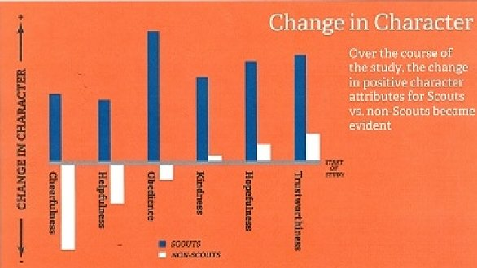

Does scouting change lives?
YOU BET!
A three-year survey of young people aged 6-12 in the Philadelphia area shows the more time kids spend in scouting the better the outcomes in character development.
The survey of 1,800 Cub Scouts and 400 non-Scouts under age 12 found youngsters who are engaged in scouting report positive changes in hopefulness, helpfulness, obedience, cheerfulness, kindness and trustworthiness.
For three years, a research team from Tufts University worked with the BSA Cradle of Liberty Council to measure the character attributes of Scouts and non-Scouts. The study was funded by the John Templeton Foundation.
At the beginning, there were no differences in character attributes between Scouts and non-Scouts,
At the end of three years, non-Scouts decreased in cheerfulness, helpfulness and obedience while Cub Scouts showed major improvement in all three character attributes. Both groups showed some improvement in kindness, hopefulness, and trustworthiness, but Cub Scouts were far ahead of the non-Scout group.
When asked what was “most important” to them, Scouts were significantly more likely than non-Scouts to choose “helping others” or “doing the right thing” versus “being smart,” “being the best,” or “playing sports.”

