Programs
- 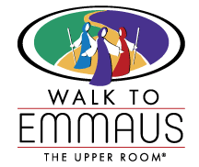Visit Site

Walk to Emmaus
The Walk to Emmaus® is a spiritual renewal program intended to strengthen the local church through the development of Christian disciples and leaders.
- 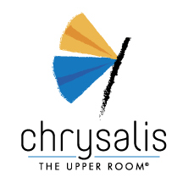Visit Site

Chrysalis
Chrysalis® is the youth and young adult version of The Walk to Emmaus®. This three-day spiritual renewal time provides an opportunity for youth and young adults to learn more about faith, to experience Christian love and support, and to make new faith commitments.
- 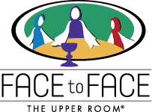Visit Site

Face to Face
Face to Face was created to provide an opportunity for seniors to experience the best of "The Walk to Emmaus" Retreat without the stresses of a three-day, 72 hour program. Face to Face is for adults ages 60 and over and is open to members of any Christian denomination who want to strengthen their spiritual lives, discover answers to their questions about faith, and are open to understanding the responsibility of living a Christian lifestyle.
- Visit Site

The Upper Room® Living Prayer Center
The Upper Room Living Prayer Center is a 24-hour, 7-day-a-week intercessory prayer ministry staffed by Christian volunteers. The Living Prayer Center recruits and trains covenant prayer groups to assist in this ministry of intercessory prayer.
- Visit Site

The Academy for Spiritual Formation®
The Academy® for Spiritual Formation is for lay and clergy persons who hunger for deep spiritual experiences. It encompasses a disciplined Christian Community which emphasizes holistic spirituality, nurturing body, mind and spirit.
- Today's Prayer
Creator God, help us to be caring, useful people who are blessings to others. In the name of Jesus. Amen.

