New officers elected
AddThis Sharing Buttons
Share to FacebookShare to TwitterShare to PrintShare to EmailShare to More2
March 8, 2016 · UMMen Foundation, NACP
- 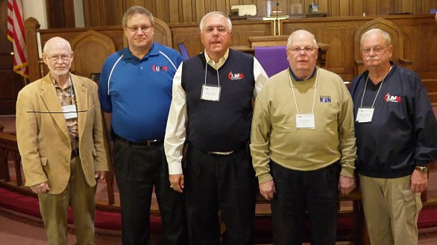

Photo: New officers of the NACP gather at front of the Andrew Price UMC chapel following their March 4 election. From left: Ken Tielke, Cary Loesing, Steve Nailor, Lee Donley and Wayne Prejean
New officers elected
NASHVILLE, Tenn.––The National Association of Conference Presidents (NACP) elected new officers to serve in the 2016-2019 quadrennium.
Steve Nailor, president of the Northern Illinois Conference UM Men, was elected NACP president. Lee Donley, former president of the North Central Jurisdiction and NACP secretary was elected first vice president. Wayne Prejean, president of the Louisiana Annual Conference UM Men, was elected second vice president and Cary Loesing, president of the North Georgia Annual Conference UM Men was elected secretary, and Ken Tielke, former president of the South Central Jurisdiction UM Men, was elected treasurer.
Jurisdictional officers:
Western: Richard Kim
South Central: Ken Tielke
Southeastern: Hank Dozier
North Central Ken Hudgins
Northeastern: Wayne Custer

Officers of the UM Men Foundation
President: Glenn Wintemberg
Vice President: Larry Dozier
Secretary: Bill Mooney
Treasurer: Gard Wayt

