GCUMM Staff

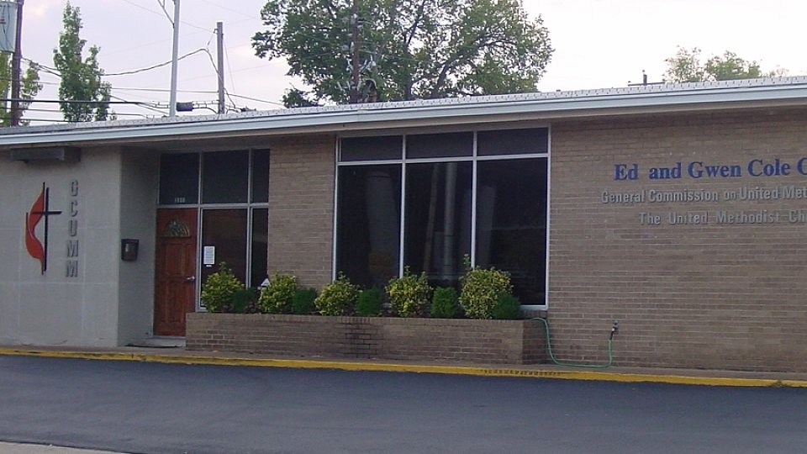

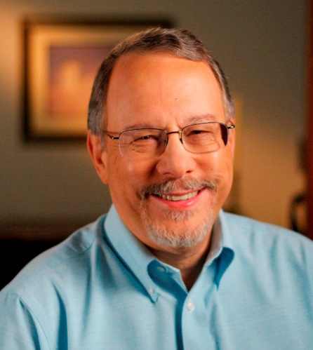

Gilbert C. Hanke
General Secretary
615-620-7267 ghanke@gcumm.org

Gilbert C. Hanke

General Secretary/ Chief Executive Officer

Martha Davis
Chief Operating Officer
615-620-7266
mdavis@gcumm.org

Martha Davis

Chief Operating Officer

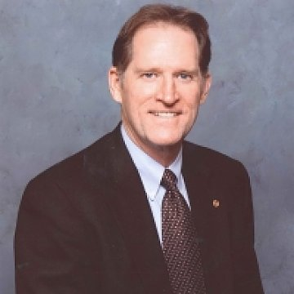
Larry Coppock
Director, Office of Civic Youth-Serving
Agencies/Scouting
615-620-7261
lcoppock@gcumm.org

Larry Coppock

National Director of Scouting Ministries

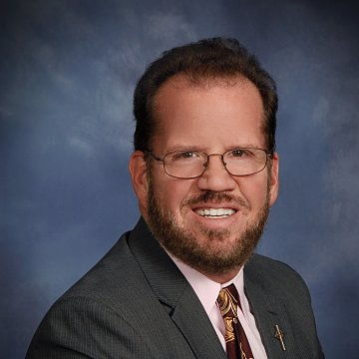

Rev. Dr. Rick Vance
National Director of Men’s Ministries
615-620-7277
rvance@gcumm.org

Rev. Dr. Rick Vance

National Director of Men's Ministries

Ann Waller
Staff Accountant
615-620-7263
awaller@gcumm.org

Ann Waller

Staff Accountant

Joe Strausbaugh
Charter System Administrator
615-620-7269
jstrausbaugh@gcumm.org

Joseph Strausbaugh

Charter System Administrator

Marc Stowe
Assistant, Office of Civic Youth-Serving
Agencies/Scouting & UMMen Foundation
615-620-7262
mstowe@gcumm.org

Marc Stowe

Scouting Ministry Assistant

Rich Peck
Editor
615-620-7264
rpeck@gcumm.org

Rich Peck

Editor

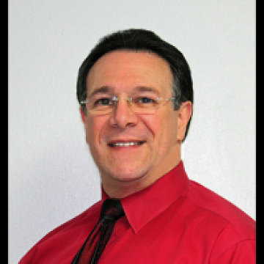

Mark Lubbock
Deployed Staff
mlubbock@gcumm.org

Mark Lubbock

Deployed Staff

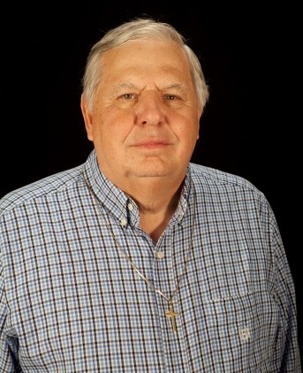

Mark Dehority
Deployed Staff
mdehority@gcumm.org

Mark Dehority

Deployed Staff

Greg Arnold
Deployed Staff
garnold@gcumm.org

Greg Arnold

Deployed Staff

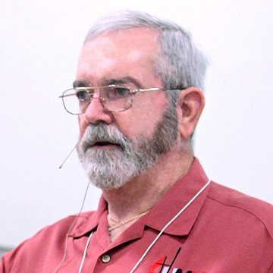

Jim Boesch
Deployed Staff
jboesch@gcumm.org

Jim Boesch

Deployed Staff

Board of Directors

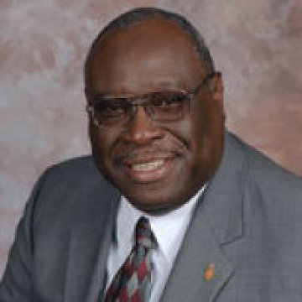

Bishop James E. Swanson, Sr.
President GCUMM
bishop@mississippi-umc.org

Bishop James E. Swanson, Sr.

President

Bishop Gary Mueller
Vice President GCUMM
bishop@arumc.org

Bishop Gary Mueller

Vice President

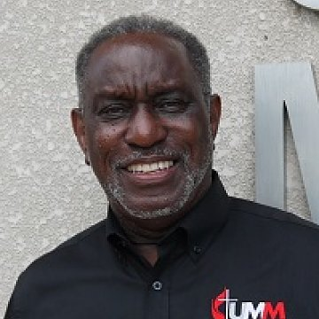

Hank Dozier
SEJ UMM President/Secretary
hdozier3@carolina.rr.com

Hank Dozier

SEJ UMM President/Secretary

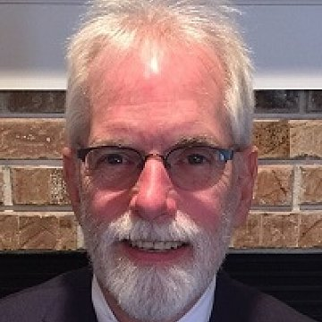

Glen Wintemberg
UMM Foundation President/Treasurer
unitvent@yahoo.com

Glenn Wintemberg

UMM Foundation President/Treasurer

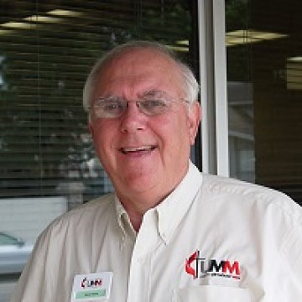

Steve Nailor
National President UMM (NACP)
sdnailor@comcast.net

Steve Nailor

National President UMM

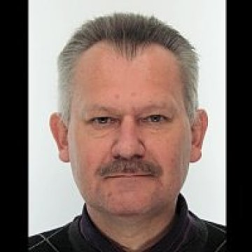

Tarmo Lilleoja
Estonia Central Conference Member
tarmo@lilleoja.com

Tarmo Lilleoja

Estonia Central Conference Member

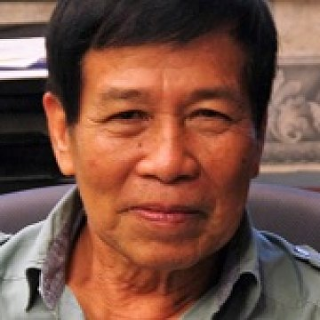

Carlos Manio
Philippines Central Conference President
caloymanio@yahoo.com

Carlos Manio

Philippines Central Conference Member

Ken Hudgins
NCJ President UMM
kwhudgins@comcast.net

Ken Hudgins

NCJ President UMM

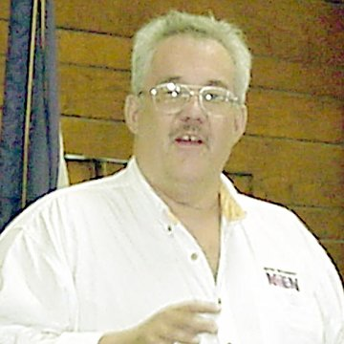

Wayne Custer
NEJ President UMM
wcuster855@aol.com

Wayne Custer

NEJ UMM President

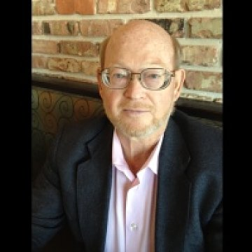

Kenneth Tielke
SCJ President UMM
kenwtielke@aol.com

Kenneth Tielke

SCJ UMM President

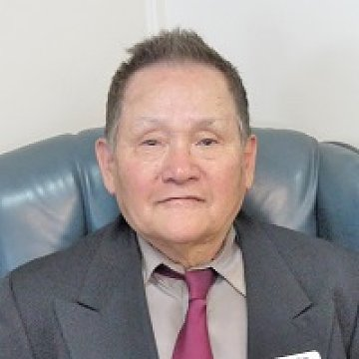

Richard Kim
WJ President UMM
richardkimc@gmail.com

Richard Kim

WJ President UMM

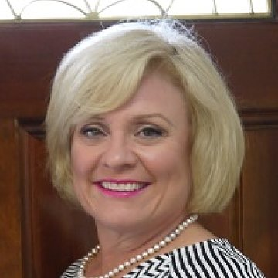

Rev. Dr. Jennifer A. Wilson
NCJ At Large Member
jen_wilson@wheatlandsalem.org

Rev. Dr. Jennifer A. Wilson

NCJ At Large Member

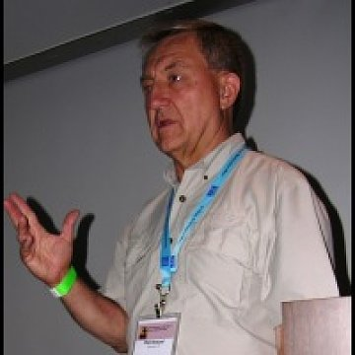

Phil Howard
NCJ At Large Member
phoward@interdesign.com

Phil Howard

NCJ At Large Member

Amanda Vogt
SCJ At Large Young Adult
venturingpresident@yahoo.com

Amanda Vogt

SCJ At Large Young Adult

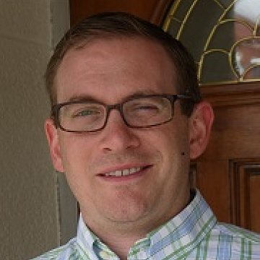

Rev. Ben Trammell
SCJ At Large Member
bdtram@gmail.com

Rev. Ben Trammell

SCJ At Large Member

Rev. Bernardo Zapata
SEJ At Large Member
bzapzta@bartlettumc.org

Rev. Bernardo Zapata

SEJ At Large Member

Rev. Dr. Scott Pickering
SEF At Large Member
sdp2011@icloud.com

Rev. Dr. Scott Pickering

SEJ At Large Member

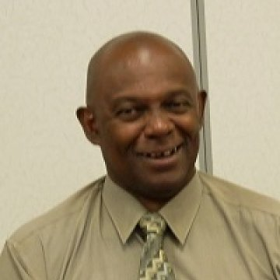

Reginald Grant
WJ At Large Member
reginaldreggiegrant@gmail.com

Reginald Grant

WJ At Large Member

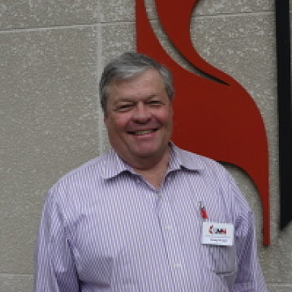

Doug Wright
WJ At Large Member
Dwright5@centurylink.net

Doug Wright

WJ At Large Member

Website: www.gcumm.org General email: gcumm@gcumm.org
Toll Free: 866-297-4312
Updated: December 19, 2014

Who we are
The 2016 United Methodist Book of Discipline charges the General Commission on United Methodist Men with the “primary oversight for the coordination and resourcing of men’s ministry with The United Methodist Church.” (paragraph 2302)

Brief history
By a margin of 80% to 20%, the General Conference of 1996 approved the creation of the General Commission on United Methodist Men (GCUMM), effective January 1, 1997. The GCUMM assumed the responsibilities of the former Division of United Methodist Men of the General Board of Discipleship. A 23-member Board of Directors was established by General Conference to oversee the work of the Commission.

Mission
To Help Men Grow In Christ, So Others May Know Christ.

Board of Directors
The GCUMM Board of Directors is responsible for communicating through its staff to its affiliates and partners, and the UMC, the mission and vision of the GCUMM to make disciples of Jesus Christ for the transformation of the world.

Staff
The GCUMM staff is charged with conducting operations to carry out the mission and vision of the Board of Directors concerning ministries with men and scouting as directed by the UM Book of Discipline, and including strategic plans. They are also responsible for training and resourcing affiliates, partners and other leaders to accomplish these goals. See our complete staff listing.

Partners
Our partners are associated with each other, especially in action.
- Building Brothers
- Man in the Mirror
- Society of St. Andrew
- Stop Hunger Now
- Upper Room Prayer Center
- All Agencies of the UMC
- Hope of Hearing
- Big Brothers Big Sisters
- Boy Scouts of America
- Camp Fire USA
- Girl Scouts of the USA
- Programs of Religious Activities with Youth (PRAY)
- Disciple Bible Outreach Ministries

Affiliates
Our Affiliates are closely associated with another, typically in a dependent position.

National Association of Conference Presidents (NACP)
NACP is responsible for implementing procedures recommended by the GCUMM board of Directors and their staff to accomplish these goals through their leadership network, i.e., conference, district and local churches.

United Methodist Men Foundation
UMM Foundation board members are responsible for providing funds necessary to achieve these goals.

Contact Us
General Commission on United Methodist Men
1000 17th Ave S.
Nashville, TN 37212
615-340-7145 · Toll Free: 866-297-4312
gcumm@gcumm.org

