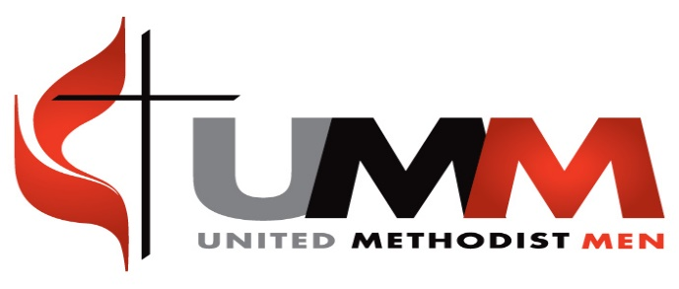
Local United Methodist Men
Organizational/Resource Handbook
Training Agenda
AM
8:00 Registration, refreshments, fellowship
8:30 Welcome, Introduction, devotion, Praise, Prayer
9:00 Workshop 1, Sections 1,2,3,4
9:30 Workshop 2, Section 5, 6, 7
10:30 Fellowship Break
10:45 Workshop 3, Section 8, (Upper Room Training Video), 9, 10, 11
12:00 Prayer & Lunch
PM
1:00 Prayer & Praise
1:15 Workshop 4, Section 11, 12, 13, 14
2:30 Fellowship Break
2:45 Workshop 5, Section 15, 16, 17, 18, 19, 20, 22
3:45 Closing Moments, Evaluation

Thank you for being here today and for preparing yourself to do the Lord’s work through United Methodist Men with our Lord Jesus Christ. Always remember that United Methodist Men, in spite of its name, is always open to all men, not just Methodist. It is about Men’s Ministry or Ministry through Men in its nature and its purpose is to make disciples of men for the service of our Lord Jesus Christ. It is my hope and prayer that this day will be advantageous for yourself, but mostly that everything we did was pleasing to our Lord and acceptable in his sight. May God bless and keep you as you depart to do His Ministry!

Ken Hudgins
Men’s Ministry Specialist
United Methodist Men

